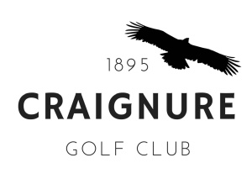
CRAIGNURE GOLF CLUB
Membership Application/Renewal 2026/27
All fees due by 1st April 2026
Name:
Address:

Post Code:
Telephone:
Email:
Date of birth:
Are you happy for all club communications to be sent by email? |  |  | YES/NO
Home Club:
(if not Craignure)
Previous club?
Membership Type: |  | Fee: | £
Locker fee £10 (please check availability) |  |  | £
Total: |  |  | £
Date:
Data Protection
For details on how your data is processed please refer to the Privacy Notice on our website: http://www.craignuregolfclub.co.uk/downloads
Payments
Please pay direct to Clydesdale Bank, sort code 82-68-18, account Craignure Golf Club 30180442; and also email this form to: info@craignuregolfclub.co.uk.
Or pay by cheque payable to Craignure Golf Club and post to:
The Treasurer, Craignure Golf Club, Scallastle, Isle of Mull, PA65 6BA

